# 4-digit 7-segment digital tube display experiment

## Introduction

We have used 7-segment digital tubes before, so we know that when we want to display multiple numbers, we need a multi-digit digital tube. Next, we will introduction 4-digit 7-segment digital tubes. In fact, each 7-segment digital tube is almost the same as the tube used before. In this experiment, we will use Raspberry Pi as the main board to drive 4-digit 7-segment common anode digital tubes.

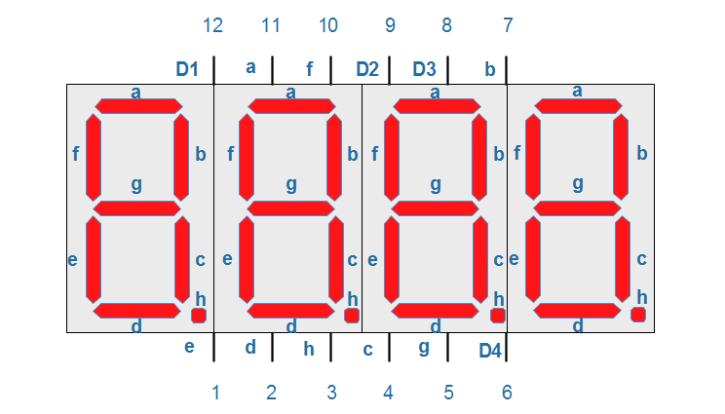

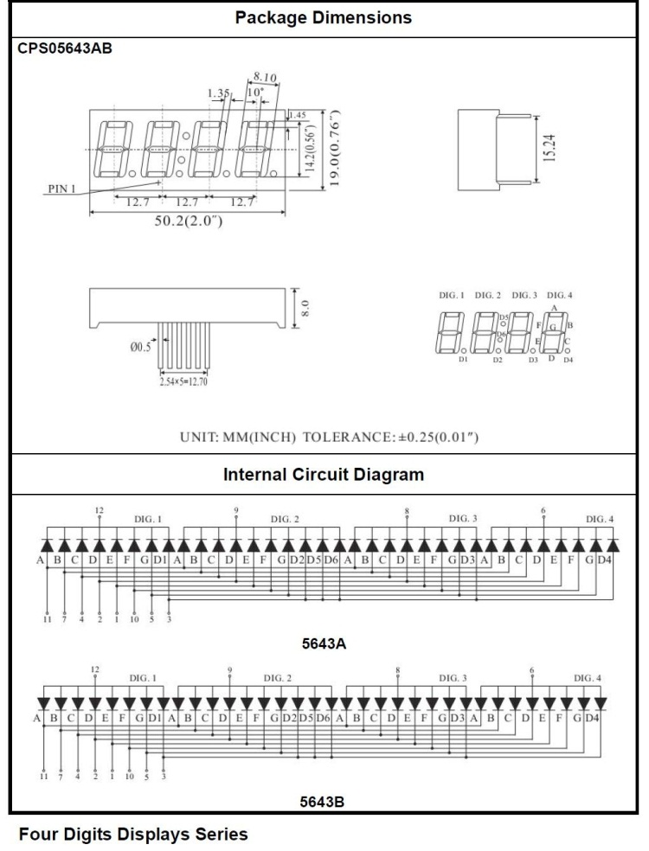

This digital tube has a total of 12 pins and the pin number in the upper left corner is 12. Eight of its pins are used to light up the “abcdefgh”segment tube, and the remaining four pins D1, D2, D3 and D4 are used to represent “bit” pins. When the corresponding “bit” pin of these four digital tubes is high level voltage, it will be lit. The display principle of these four digital tubes is to continuously scan the D1, D2, D3 and D4 pins, and then light the corresponding eight-segment tubes in sequence. Since the speed of lighting up the digital tubes is so fast that humans eyes can not see it, so it looks like four digital tubes are displayed at the same time.

Based on the principles introduced above, we will now make a simulated countdown time bomb similar to the movie. This bomb will explode in a minute.

## Experimental principle

The most import purpose of this program is how to dynamically scan these four digital tubes. In fact, from the single digital tube display experiment we have done before, it is quite easy to realize the simultaneous display of these four digital tubes. As it is a common anode digital tube, first of, we set D1，D2，D3 and D4 to low level voltage and all of the LEDs will be off, and then we output the truth table of “abcdefgh” to the corresponding GPIO port, and select the corresponding bit pin are scanned continuously. How to achieve the 1 minute countdown effect? We delay for about 1 second, subtract 1 from the countdown time, and then constantly refresh the time displayed on this digital tube.

## Experimental purpose

The aim of this experiment is to cyclically display the numbers 0-60 by dynamically scanning a 4-digit 7-segment digital tube.

## Component list

* Raspberry Pi main board
* T-Cobbler Plus expansion board
* Cable
* 4-digit 7-segment digital tube * 1
* 1k Resistor * 12
* Several jumper wires

## Wiring

|  |  |
| --- | --- |
| Raspberry Pi Board | Digital Tube |
| IO29(wiringPi)/21(BCM) | (a) |
| IO28(wiringPi)/20(BCM) | (b) |
| IO25(wiringPi)/26(BCM) | (c) |
| IO24(wiringPi)/19(BCM) | (d) |
| IO23(wiringPi)/13(BCM) | (e) |
| IO26(wiringPi)/12(BCM) | (f) |
| IO6(wiringPi)/25(BCM) | (g) |
| IO22(wiringPi)/6(BCM) | (h) |
| IO4(wiringPi)/23(BCM) | (d1) |
| IO5(wiringPi)/24(BCM) | (d2) |
| IO27(wiringPi)/16(BCM) | (d3) |
| IO3(wiringPi)/22(BCM) | (d4) |

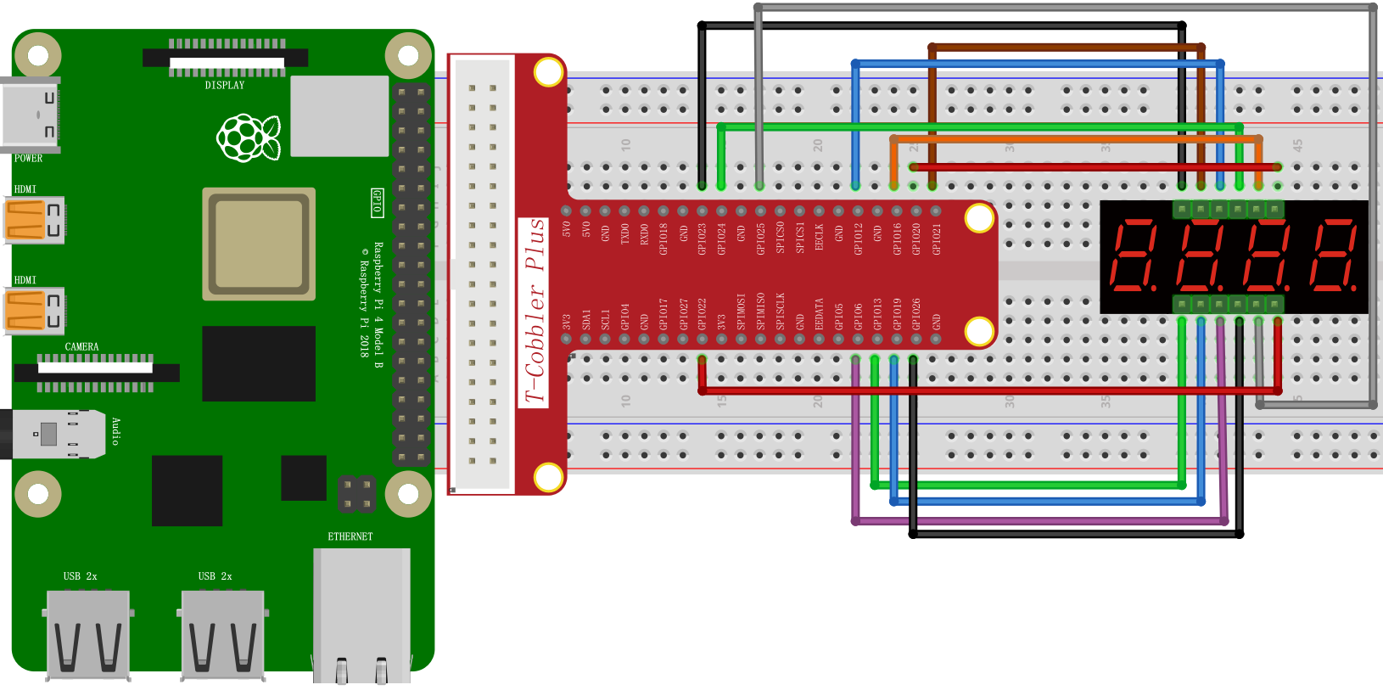

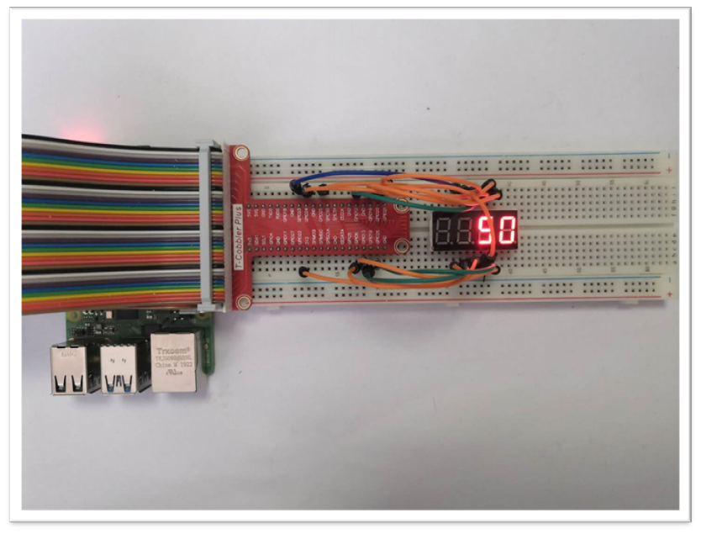

## C++ partial program

|  |
| --- |
| #include <iostream>  #include <wiringPi.h>  #include "SegmentDisplay.h"  **using** **namespace** std**;**  #define LED_A 29  #define LED_B 28  #define LED_C 25  #define LED_D 24  #define LED_E 23  #define LED_F 26  #define LED_G 6  #define LED_H 22  #define LED_D1 4  #define LED_D2 5  #define LED_D3 27  #define LED_D4 3  int main **()**  **{**  wiringPiSetup**();**  SegmentDisplay _4Bit_7SegmentDisplay**(**LED_A**,** LED_B**,** LED_C**,** LED_D**,** LED_E**,** LED_F**,** LED_G**,** LED_H**,** LED_D1**,** LED_D2**,** LED_D3**,** LED_D4**);**  int ShowTime **=** 0**,** count **=** 0**;**  **while(**1**)**  **{**  **if** **(**ShowTime **>** 60 **)**  **{**  ShowTime **=** 0 **;**  **}**  _4Bit_7SegmentDisplay**.**DisplayChar**((**int**)**ShowTime**);**  ShowTime**++** **;**  **}**  **}** |

**Python program**

|  |
| --- |
| #!/usr/bin/env python  import RPi**.**GPIO as GPIO  import time  BIT0 **=** 22  BIT1 **=** 16  BIT2 **=** 24  BIT3 **=** 23  segCode **=** **[**0xc0**,** 0xf9**,** 0xa4**,** 0xb0**,** 0x99**,** 0x92**,** 0x82**,** 0xf8**,** 0x80**,** 0x90**]** #0**~**9  pins **=** **[**21**,** 20**,** 26**,** 19**,** 13**,** 12**,** 25**,** 6**,** 22**,** 16**,** 24**,** 23**]**  bits **=** **[**BIT0**,** BIT1**,** BIT2**,** BIT3**]**  def print_msg**():**  print **(**'Program is running...'**)**  print **(**'Please press Ctrl+C end the program...'**)**  def digitalWriteByte**(**val**):**  GPIO**.**output**(**21**,** val **&** **(**0x01 **<<** 0**))**  GPIO**.**output**(**20**,** val **&** **(**0x01 **<<** 1**))**  GPIO**.**output**(**26**,** val **&** **(**0x01 **<<** 2**))**  GPIO**.**output**(**19**,** val **&** **(**0x01 **<<** 3**))**  GPIO**.**output**(**13**,** val **&** **(**0x01 **<<** 4**))**  GPIO**.**output**(**12**,** val **&** **(**0x01 **<<** 5**))**  GPIO**.**output**(**25**,** val **&** **(**0x01 **<<** 6**))**  GPIO**.**output**(**6**,** val **&** **(**0x01 **<<** 7**))**  def hide**():**  GPIO**.**output**(**BIT0**,** GPIO**.**LOW**)**  GPIO**.**output**(**BIT1**,** GPIO**.**LOW**)**  GPIO**.**output**(**BIT2**,** GPIO**.**LOW**)**  GPIO**.**output**(**BIT3**,** GPIO**.**LOW**)**  def show**():**  GPIO**.**output**(**BIT0**,** GPIO**.**HIGH**)**  GPIO**.**output**(**BIT1**,** GPIO**.**HIGH**)**  GPIO**.**output**(**BIT2**,** GPIO**.**HIGH**)**  GPIO**.**output**(**BIT3**,** GPIO**.**HIGH**)**  def showNum**(**bit**,**num**):**  hide**()**  GPIO**.**output**(**bits**[**bit**],** GPIO**.**HIGH**)**  digitalWriteByte**(**segCode**[**num**])**  time**.**sleep**(**0.025**)**  def display_3**(**num**):**  b0 **=** num **%** 10  b1 **=** int**(**num **%** 100 **/** 10 **)**  b2 **=** int**(**num **%** 1000 **/** 100**)**  b3 **=** int**(**num **/** 1000**)**  **if** num **<** 10**:**  showNum**(**0**,**b0**)**  elif num **>=** 10 **and** num **<** 100**:**  showNum**(**0**,** b0**)**  showNum**(**1**,** b1**)**  elif num **>=** 100 **and** num **<** 1000**:**  showNum**(**0**,** b0**)**  showNum**(**1**,** b1**)**  showNum**(**2**,** b2**)**  elif num **>=** 1000 **and** num **<** 10000**:**  showNum**(**0**,** b0**)**  showNum**(**1**,** b1**)**  showNum**(**2**,** b2**)**  showNum**(**3**,** b3**)**  **else:**  print **(**'Out of range, num should be 0~9999 !'**)**  def setup**():**  #GPIO.setmode(GPIO.BOARD) #Number GPIOs by its physical location  GPIO**.**setmode**(**GPIO**.**BCM**)**  **for** pin in pins**:**  GPIO**.**setup**(**pin**,** GPIO**.**OUT**)** #set all pins' mode is output  GPIO**.**output**(**pin**,** GPIO**.**HIGH**)** #set all pins are high level**(**3.3V**)**  def loop**():**  **while** True**:**  print_msg**()**  **for** i in range**(**60**):**  display_3**(**i**)**  def destroy**():** #When program ending**,** the function is executed**.**  **for** pin in pins**:**  GPIO**.**output**(**pin**,** GPIO**.**LOW**)** #set all pins are low level**(**0V**)**  GPIO**.**setup**(**pin**,** GPIO**.**IN**)** #set all pins' mode is input  **if** __name__ **==** '__main__'**:** #Program starting from here  setup**()**  **try:**  loop**()**  except KeyboardInterrupt**:**  destroy**()** |

## Java program

|  |
| --- |
| **import** com**.**pi4j**.**wiringpi**.**Gpio**;**  **import** java**.**util**.**List**;**  **import** java**.**util**.**ArrayList**;**  **import** java**.**util**.**Scanner**;**  enum MODE  **{**  SEGMENT_DISPLY_1BIT**,**  SEGMENT_DISPLY_4BIT**,**  SEGMENT_DISPLY_8BIT**;**  **}**  public class Digital_Tube **{**  char dight_pin**[]** **=** **{**29**,** 28**,** 25**,** 24**,** 23**,** 26**,** 6**,** 22**};**  char dight_display**[]** **=** **{**0xC0**,** 0xF9**,** 0xA4**,** 0xB0**,** 0x99**,** 0x92**,** 0x82**,** 0xF8**,** 0x80**,** 0x90**,** 0x00**};**  char dight_select_pin**[]** **=** **{**4**,** 5**,** 27**,** 3**};**  List list **=** **new** ArrayList**();**  MODE mode**;**  static **{**  Gpio**.**wiringPiSetup**();**  **}**  void SegmentDisplay**()** **{**  mode **=** MODE**.**SEGMENT_DISPLY_1BIT**;**  **for** **(**int i **=** 0**;** i **<** 8**;** i**++)** **{**  Gpio**.**pinMode**(**dight_pin**[**i**],** Gpio**.**OUTPUT**);** //set all led diplay array pin output mode  Gpio**.**digitalWrite**(**dight_pin**[**i**],** Gpio**.**HIGH**);**  **}**  **}**  void SegmentDisplay**(**int segment**)** **{**  mode **=** MODE**.**SEGMENT_DISPLY_4BIT**;**  **for** **(**int i **=** 0**;** i **<** 8**;** i**++)** **{**  Gpio**.**pinMode**(**dight_pin**[**i**],** Gpio**.**OUTPUT**);** //set all led diplay array pin output mode  Gpio**.**digitalWrite**(**dight_pin**[**i**],** Gpio**.**LOW**);**  **}**  **for** **(**int i **=** 0**;** i **<** 4**;** i**++)** **{**  Gpio**.**pinMode**(**dight_select_pin**[**i**],** Gpio**.**OUTPUT**);** //set all led diplay array pin output mode  Gpio**.**digitalWrite**(**dight_select_pin**[**i**],** Gpio**.**LOW**);**  **}**  **}**  void TurnOffAllLed**()** **{**  **for** **(**int i **=** 0**;** i **<** 8**;** i**++)**  Gpio**.**digitalWrite**(**dight_pin**[**i**],** Gpio**.**LOW**);**  **if** **(**mode **==** MODE**.**SEGMENT_DISPLY_4BIT**)** **{**  **for** **(**int i **=** 0**;** i **<** 4**;** i**++)**  Gpio**.**digitalWrite**(**dight_select_pin**[**i**],** Gpio**.**LOW**);**  **}**  **}**  void numble2dis**(**int numble**)** **{**  int numble_bit **=** 0**;**  int bit_base **=** 1000**;**  **for** **(**numble_bit **=** 0**;** numble_bit **<** 4**;** numble_bit**++** **)** **{**  **if** **(**numble**/**bit_base **!=** 0**)** **{**  list**.**add**(**numble_bit**,** numble**/**bit_base**);**  numble **=** numble**%**bit_base**;**  **}** **else** **{**  list**.**add**(**numble_bit**,** 0**);**  **}**  bit_base **=** bit_base **/** 10**;**  **}**  **}**  void Display_One_Char**(**int n**)** **{**  char ch **=** dight_display**[**n**];**  **if** **(**n **<** 10**)** **{**  **for** **(**int i **=** 0**;** i **<** 8**;** i**++)** **{**  **if** **((**ch **&** **(**1 **<<** i**))** **==** 0**)** **{**  Gpio**.**digitalWrite**(**dight_pin**[**i**],** Gpio**.**LOW**);**  **}** **else** **{**  Gpio**.**digitalWrite**(**dight_pin**[**i**],** Gpio**.**HIGH**);**  **}**  **}**  **}**  **}**  void Display_Four_Char**(**int n**)** **{**  char ch **=** dight_display**[**n**];**  **if** **(**n **<** 10**)** **{**  **for** **(**int i **=** 0**;** i **<** 8**;** i**++)** **{**  **if** **((**ch **&** **(**1 **<<** i**))** **==** 0**)** **{**  Gpio**.**digitalWrite**(**dight_pin**[**i**],** Gpio**.**HIGH**);**  **}** **else** **{**  Gpio**.**digitalWrite**(**dight_pin**[**i**],** Gpio**.**LOW**);**  **}**  **}**  **}**  **}**  void DisplayChar**(**int n**)** **{**  **if** **(**mode **==** MODE**.**SEGMENT_DISPLY_4BIT**)** **{**  numble2dis**(**n**);**  **for(**int i **=** 0**;** i **<** 4**;** i**++)** **{**  Display_Four_Char**((**int**)**list**.**get**(**i**));**  Gpio**.**digitalWrite**(**dight_select_pin**[**i**],** Gpio**.**LOW**);**  Gpio**.**delay**(**5**);**  Gpio**.**digitalWrite**(**dight_select_pin**[**i**],** Gpio**.**HIGH**);**  **}**  **}**  **}**  void DisplayChar**(**char sel**,** char n**)** **{**  char ch **=** dight_display**[**n**];**  **for** **(**int i **=** 0**;** i **<** 8**;** i**++)** **{**  **if** **((**ch **&** **(**1 **<<** i**))** **==** 0**)** **{**  Gpio**.**digitalWrite**(**dight_pin**[**i**],** Gpio**.**HIGH**);**  **}** **else** **{**  Gpio**.**digitalWrite**(**dight_pin**[**i**],** Gpio**.**LOW**);**  **}**  **}**  Gpio**.**digitalWrite**(**dight_select_pin**[**sel**]** **,** Gpio**.**HIGH**);**  **}**  public static void main**(**String**[]** args**)** **{**  Digital_Tube digital_tube **=** **new** Digital_Tube**();**  digital_tube**.**SegmentDisplay**(**4**);**  int ShowTime **=** 0**,** count **=** 0**;**  **while** **(true)** **{**  **for** **(**int i **=** 60**;** i **>=** 0**;** i**--)** **{**  **if** **(**ShowTime **>** 60 **)** **{**  ShowTime **=** 0 **;**  **}**  digital_tube**.**DisplayChar**(**ShowTime**);**  ShowTime**++** **;**  **}**  **}**  **}**  **}** |

## Experiment effect

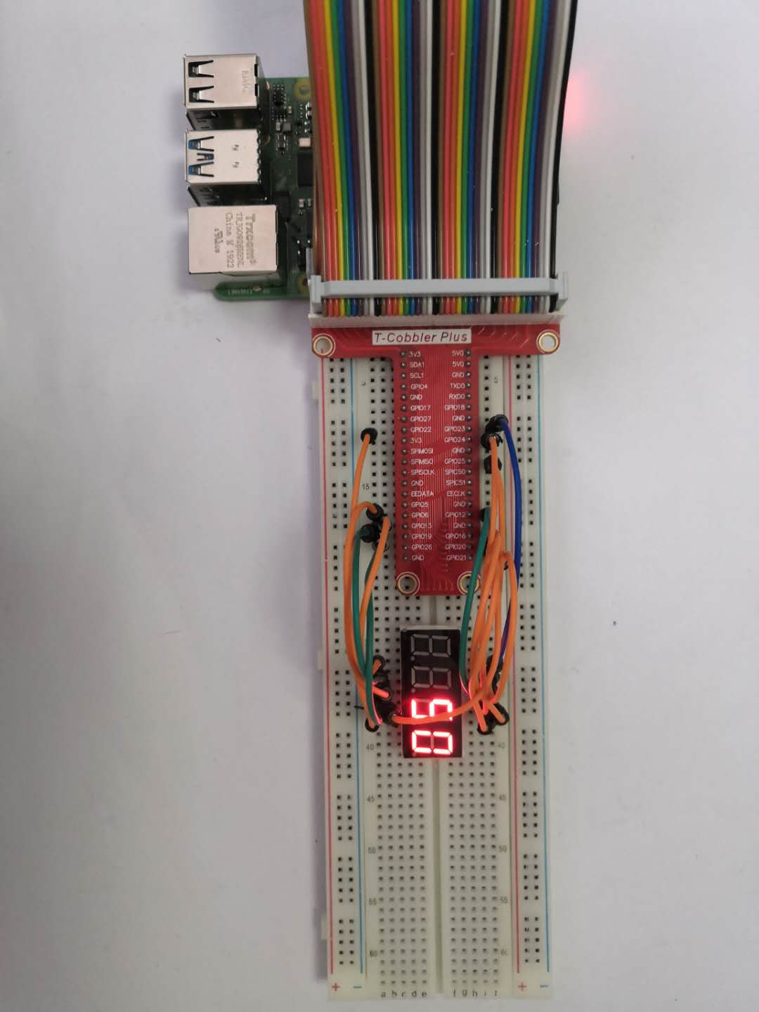

You will see the numbers 0-60 cycled displayed on the digital tube.